活动如下：

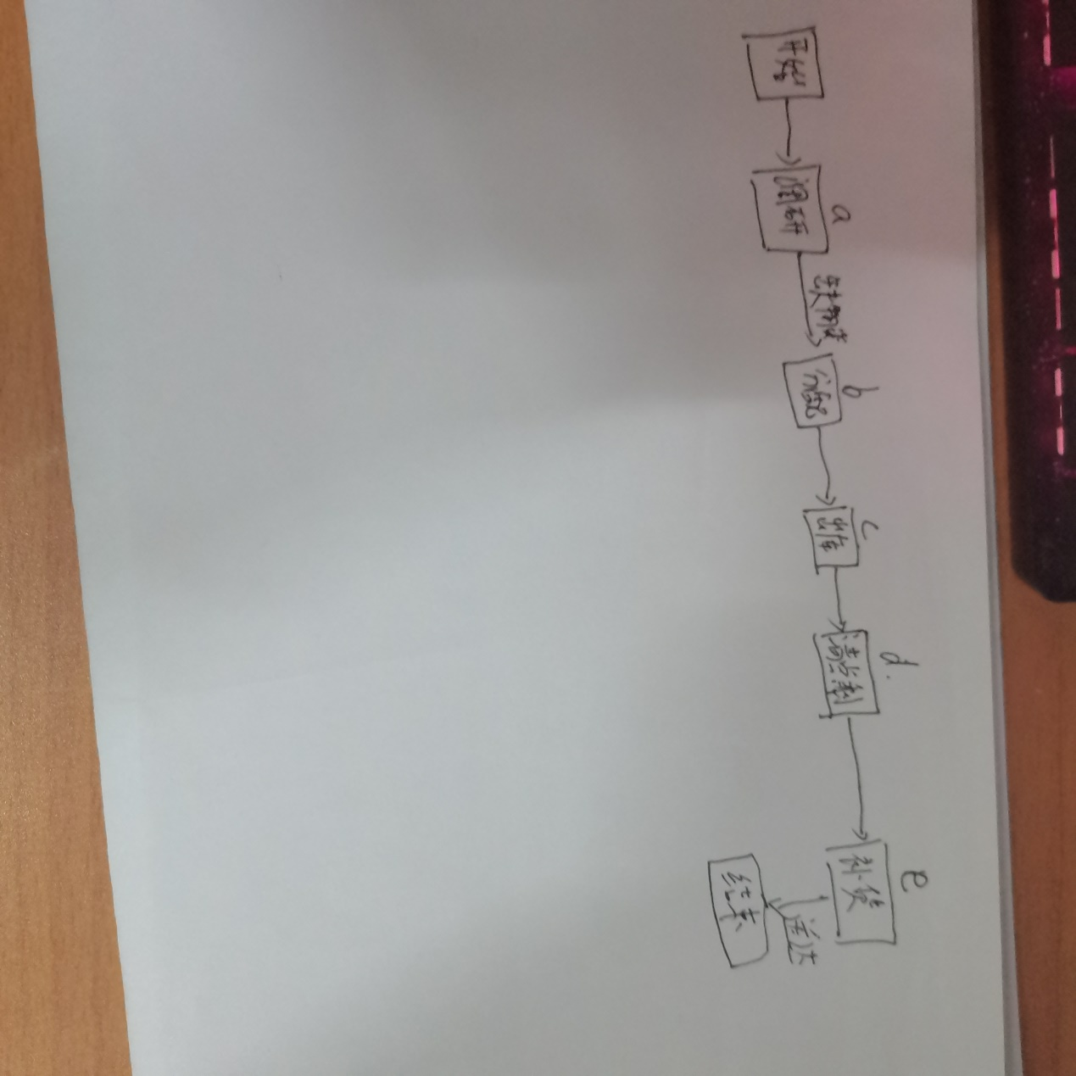

|  |  |  |  |  |  |
| --- | --- | --- | --- | --- | --- |
| 任务\估计值 | 最乐观 | 最可能 | 最悲观 | E | ∂（标准差） |
| a | 1 | 1 | 2 | 7/6 | 1/6 |
| b | 3 | 4 | 6 | 25/6 | 1/2 |
| c | 1 | 1 | 2 | 7/6 | 1/6 |
| d | 3 | 4 | 6 | 21/6 | 1/2 |
| e | 1 | 1 | 3 | 4/3 | 1/3 |

E=Ea+Eb+...+Ee=11.33

∂(标准差)=1.66